Dissecting Packets: From HTTP to TLS

Wireshark Packet Analysis Project Report

Submitted By
- Name: SanthoshS
- Email: thor41361@gmail.com
- Phone: 9150883411

1. Introduction
Wireshark is a powerful network protocol analyzer used to capture and inspect packets traveling across a network. It helps cybersecurity professionals, network administrators, and students understand how communication occurs between systems.
In this project, HTTP, DNS, and TLS traffic were captured and analyzed using Wireshark. The project demonstrates how application-layer protocols operate and how packet-level analysis can help in troubleshooting and security monitoring.

2. Objective
The objective of this project is to analyze real-time network traffic using Wireshark and understand how HTTP requests, DNS resolution, and TLS handshakes appear in captured packets.

3. Tools Used
- Wireshark
- Parrot Security OS
- Web Browser
- Internet Connection

4. Procedure

Step 1 — Launching Wireshark
Wireshark was launched and packet capture was started on the active network interface.

Screenshot to Include:
- Screenshot of Wireshark interface showing active packet capture.

Step 2 — Generating HTTP Traffic
The website http://neverssl.com was visited to generate HTTP traffic. Since the website uses HTTP instead of HTTPS, Wireshark was able to capture readable HTTP GET requests.
The following display filter was applied:
http.request.method == "GET"
This filter displayed only HTTP GET request packets.

Observations:
- Source IP Address
- Destination IP Address
- Source Port
- Destination Port (80)
- HTTP Request Method: GET
- Host Information
- Browser User-Agent

5. HTTP Packet Analysis
The HTTP GET packet revealed how the client requested a webpage from the server using port 80. The packet contained request headers including host information, browser details, accepted content types, and connection parameters.
The communication was visible in plain text because HTTP does not encrypt data.

Example Details Observed:
Field | Observation
Source IP | 10.0.2.15
Destination IP | 34.107.221.82
Destination Port | 80
Request Method | GET
Protocol | HTTP

6. DNS Traffic Analysis
A DNS lookup was generated using the command:
nslookup example.com
The following display filter was applied:
dns
Wireshark displayed DNS query and response packets.

Observations:
- Domain name queried
- DNS query packet
- DNS response packet
- Resolved IP address
- Query type (A Record)

7. DNS Packet Analysis
The DNS query packet showed the client requesting the IP address associated with the domain example.com. The DNS response packet returned the corresponding IPv4 address.
DNS traffic helps systems convert human-readable domain names into machine-readable IP addresses.

Example Details Observed:
Field | Observation
Queried Domain | example.com
Query Type | AAAA
Resolved IP | 2404 : 6800: 4002: 803: : 2003
Protocol | DNS

8. TLS Handshake Analysis
An HTTPS website was visited to generate encrypted traffic:
https://example.com
The following filter was applied:
tls.handshake
Wireshark displayed TLS handshake packets including Client Hello and Server Hello.

Observations:
- TLS version
- Cipher suites
- Server Name Indication (SNI)
- Handshake negotiation details

Screenshot to Include:
- Screenshot showing Client Hello packet.
- Screenshot showing Server Hello packet.
- Screenshot of expanded Transport Layer Security section.
- Screenshot showing TLS version and Cipher Suites.
- Screenshot showing Server Name Indication (SNI).

9. TLS Packet Analysis
The Client Hello packet initiated the secure TLS communication by sending supported TLS versions, cipher suites, and extensions to the server.
The Server Hello packet responded with the selected TLS version and cipher suite to establish encrypted communication.
The Server Name Indication (SNI) extension revealed the hostname requested by the client during the TLS handshake.

Example Details Observed:
Field | Observation
TLS Version | TLS 1.2 / TLS 1.3
Cipher Suite | TLS_AES_128_GCM_SHA256 (0x1301)
SNI | List length = 13 ,  Type = host_name(0)  Name length = 10  Name = medium.com
Protocol | TLS

10. Findings
- HTTP traffic was visible in plain text.
- DNS packets resolved domain names into IP addresses.
- TLS packets encrypted communication between client and server.
- Wireshark filters helped isolate specific protocol traffic.
- Packet analysis provides visibility into network communication and security events.

11. Conclusion
This project provided practical experience in capturing and analyzing network packets using Wireshark. HTTP, DNS, and TLS traffic were successfully inspected using protocol filters.
The analysis helped in understanding how web communication occurs across different protocol layers and demonstrated the importance of encrypted communication using TLS.
Wireshark proved to be an effective tool for troubleshooting, protocol inspection, and cybersecurity monitoring.

Screenshots

Screenshots of HTTP GET/POST requests.

GET

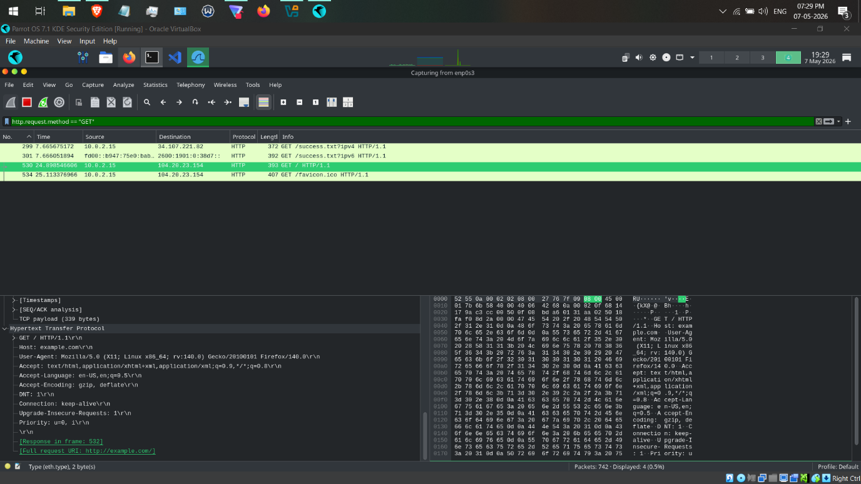

POST

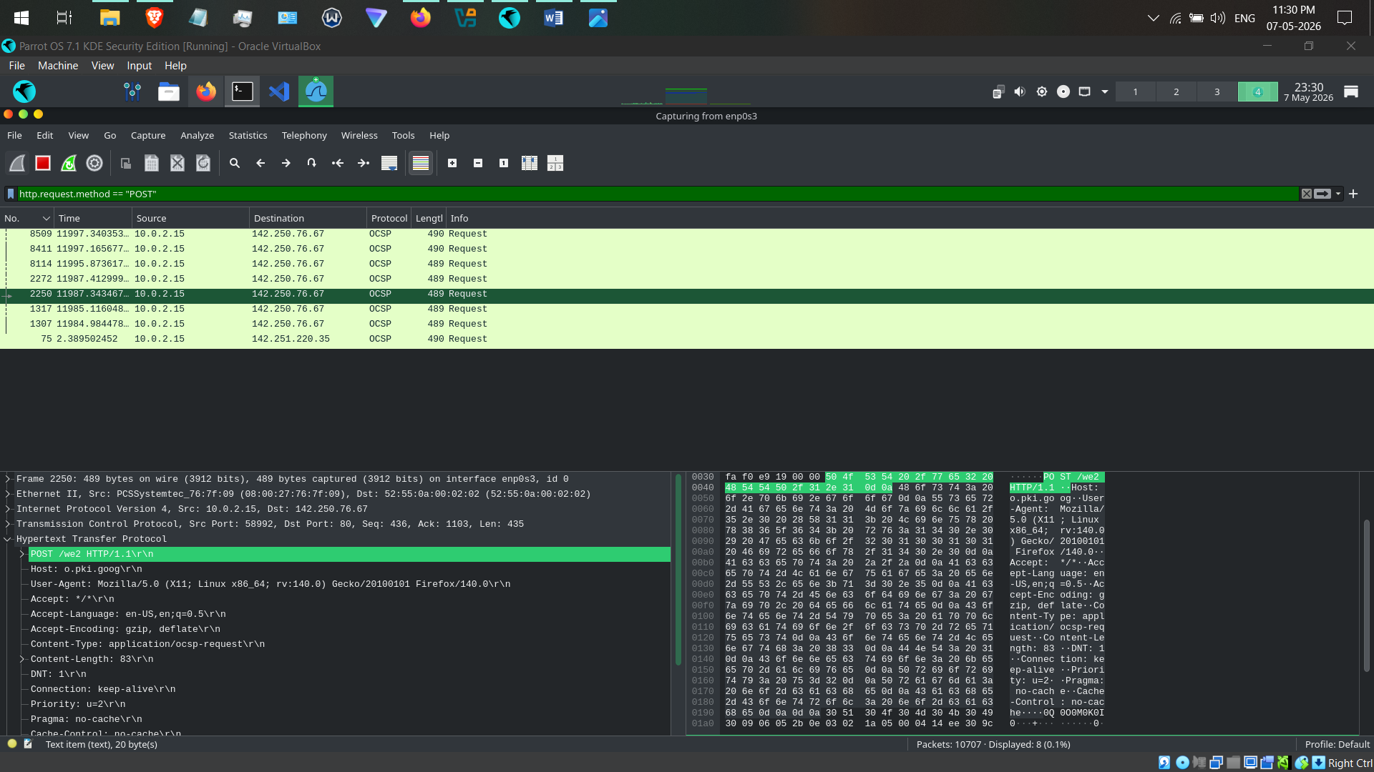

Screenshot of DNS query packet.

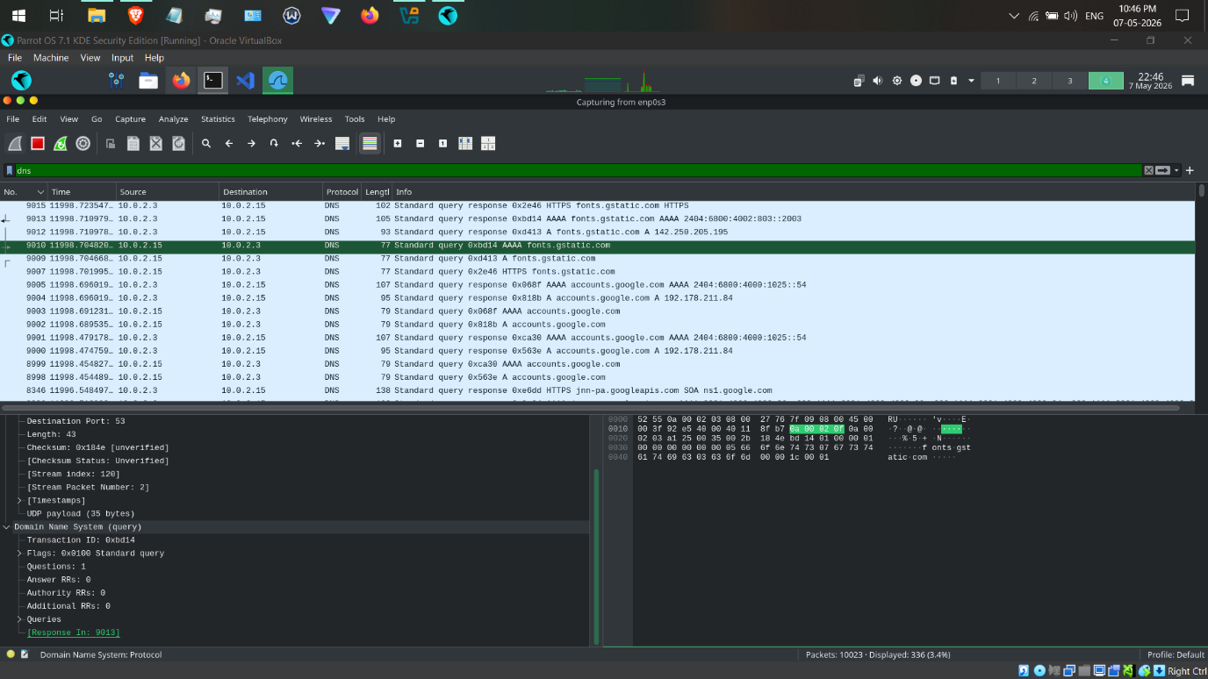
Screenshot of DNS query response packet.
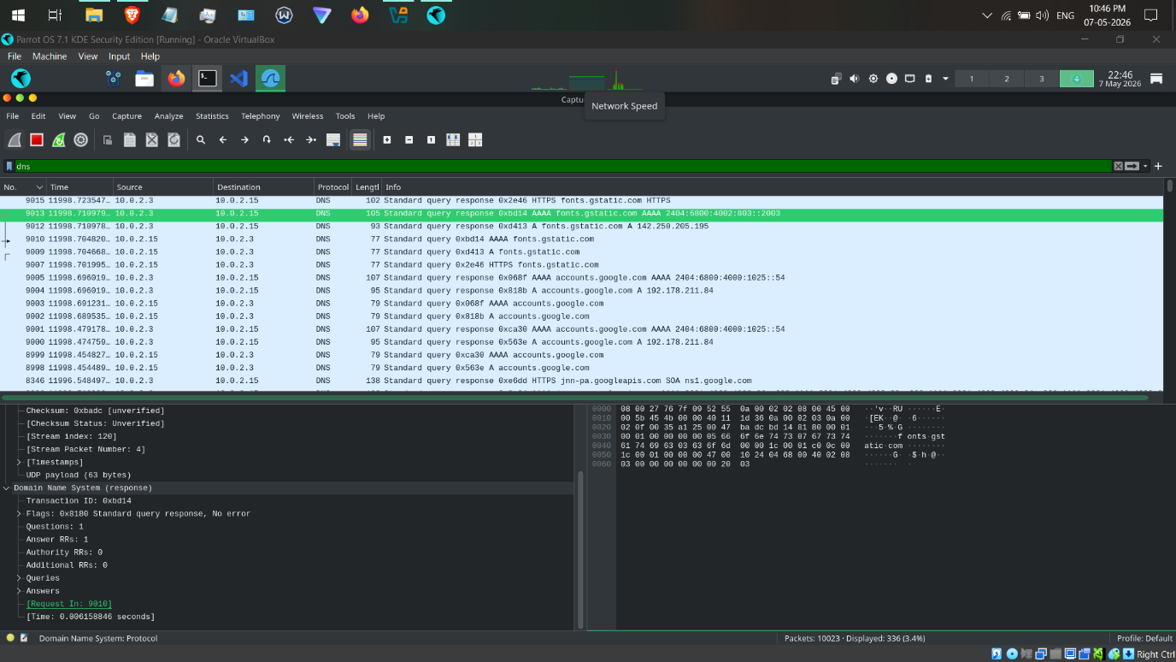
Screenshot of expanded Domain Name System section.
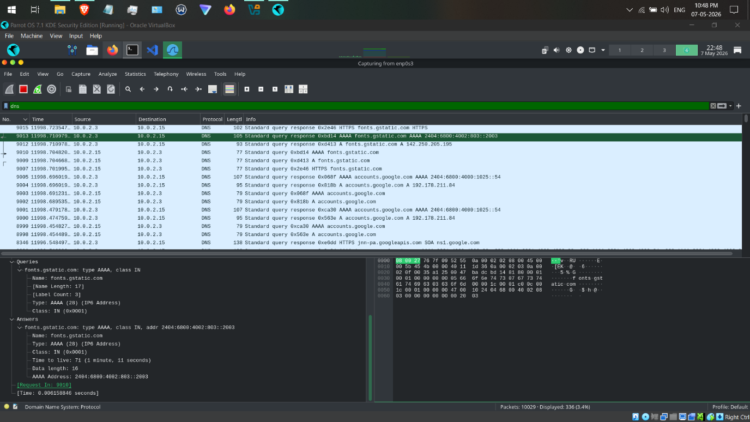
Screenshot showing Client Hello packet.

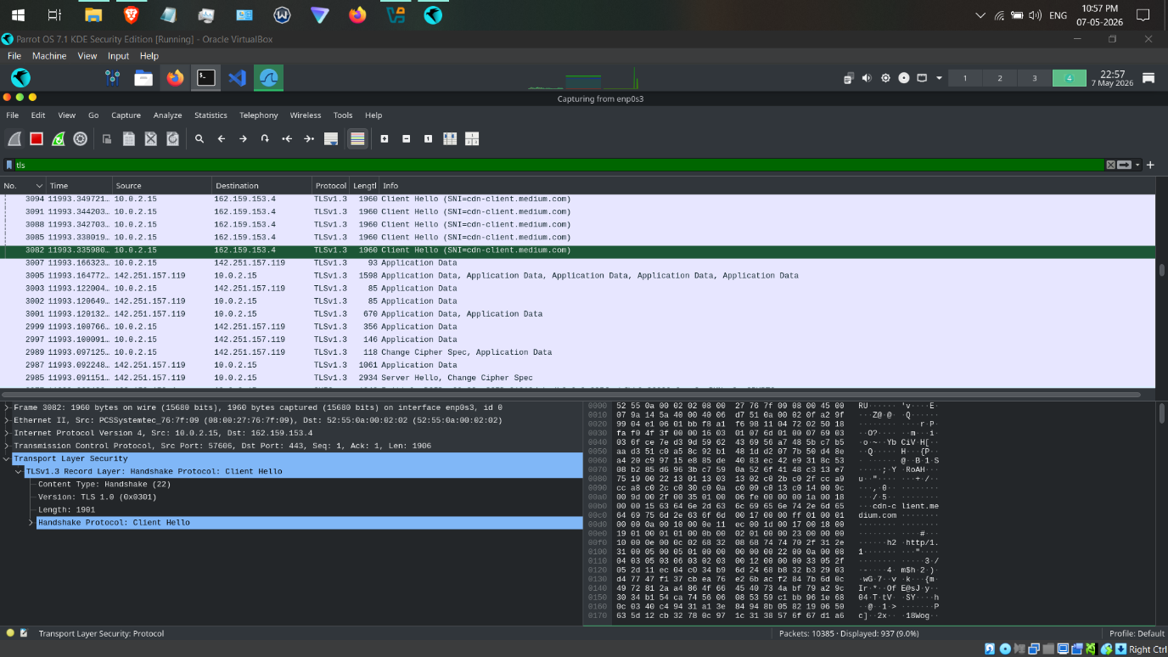
Screenshot showing Server Hello packet.
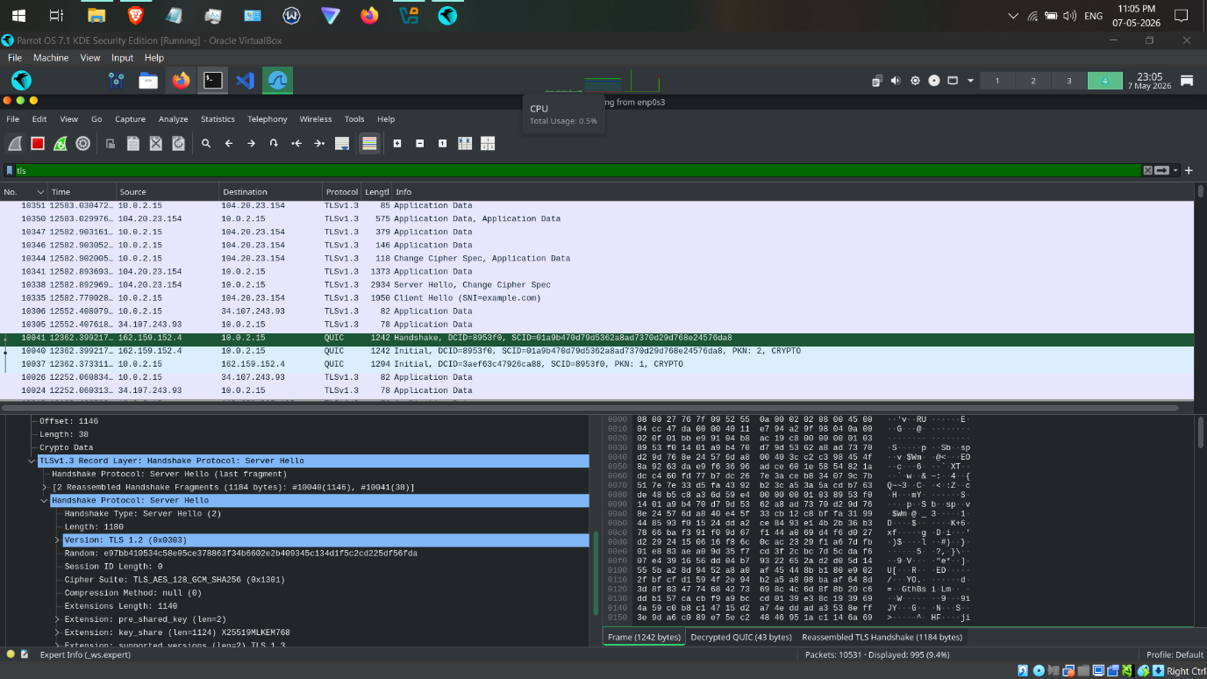
Screenshot showing TLS version and Cipher Suites.
TLS verssion

Cipher Suites

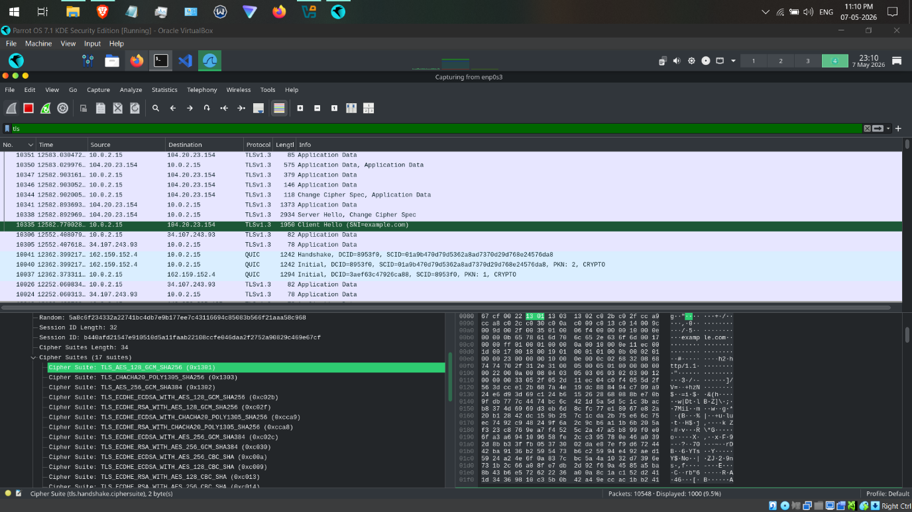
Screenshot showing Server Name Indication (SNI).
